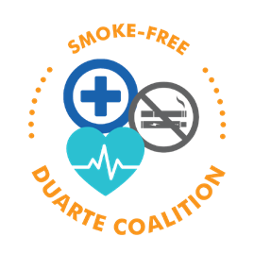

[Name]
[Address]
Duarte, CA
[ Phone number]
[ Email address]
[Date]

Dear City Council:

As a concerned Duarte youth resident, I am writing this letter to express my support for smoke-free housing policies in my community.
While we are under California “Safer at Home” order, some individuals are coping with the stress of this pandemic by smoking and vaping. Because of this, myself, my family, and neighbors may be exposed to more secondhand smoke. Just like COVID-19, secondhand smoke spreads throughout a building, and sadly, more than 100 Americans die every day from secondhand smoke exposure.
Exposure to secondhand smoke makes breathing difficult and is a significant risk factor for many health conditions. Just as social distancing and handwashing helps prevent the spread of coronavirus, eliminating secondhand smoke is critical to prevent diseases and save lives by reducing the risk of lung cancer, heart disease, and respiratory diseases.
Even before the coronavirus pandemic, secondhand smoke exposure was on the rise in California, driven mainly from increases in e-cigarettes and marijuana use. This is concerning because there is no safe level of secondhand smoke exposure. Only 100% smoke-free environments can help protect Duarte residents.
I want to request that you consider a no-smoking ordinance for multi-unit complexes in Duarte. A no-smoking rule is entirely legal and would greatly improve the and well-being of public housing residents. In LA County, sixteen out of eighty-eight cities have health already implemented local smoke-free policies.

[(Feel free to add any additional information below about how Secondhand smoke has affected you and/or why you want this ordinance to pass in your community…) ]

Thank you for your consideration.
Sincerely,

[Your Name] Duarte Resident

