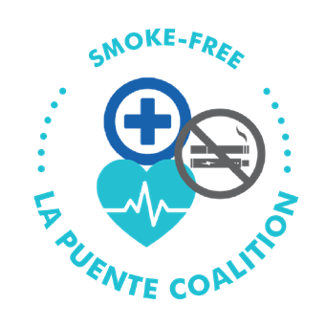

[Name]
[Address]
La Puente, CA
[Phone number]
[ Email address ]
[Date]

La Puente City Council Members

15900 E. Main Street

La Puente, CA 91744

RE: Smoke-Free Multi-Unit Housing

Dear Mayor and Honorable Councilmembers,
[YOUR ORGANIZATION/ COMPANY NAME/ OFFICE/ CLUB] is committed to be a relentless force for longer and healthier lives of residents in La Puente. We support strong measures to protect the public from secondhand smoke.
Secondhand smoke is an ongoing public health concern that puts everyone at risk, and while the State of California has made great progress to eliminate exposure in public areas, secondhand smoke still remains the third-leading cause of preventable death in the United States, and increases the risks of lung and heart disease.
The U.S. Surgeon General has concluded there is no safe level of exposure to secondhand smoke. The only way to fully protect nonsmoker residents, especially youth in La Puente, is by eliminating smoking in multi-unit housing.
According to The Center for Tobacco Policy and Organizing, 51 jurisdictions in California have adopted laws prohibiting smoking in multi-unit housing, including 16 Los Angeles County jurisdictions: El Monte, Manhattan Beach, Culver City, Glendale, Santa Monica, Huntington Park, Baldwin Park, Pasadena, South Pasadena, and Calabasas.
We want to see La Puente join these other cities in living smoke-free. Breathing in secondhand smoke that drifts in from neighboring units, balconies, and outdoor areas is an ongoing health problem in La Puente. Allegra Consulting has partnered with the Los Angeles County Public Health Department to change tobacco-related social norms and protect Duarte residents from exposure.
[name of agency/organization supports this campaign and public health interventions focused on policy as well as systemic and environmental changes in:
1) Reducing exposure to secondhand smoke for all La Puente residents;
2) Limiting tobacco promoting influences and reducing tobacco exposure to youth;
3) Improving overall indoor air quality for La Puente residents living in multi-unit homes.
Based on the data collected by Allegra Consulting, 96 percent of La Puente residents surveyed support a law that bans smoking in multi-unit housing. La Puente residents deserve smoke-free housing and we support Allegra Consulting in this campaign.
Thank you for your consideration to protect the public from secondhand smoke.

Thank you for your consideration. Sincerely,
[Your Name]

